**Reviews:**

A meeting where people analyze a software work product and recommend changes with the objective of improving quality.

Helps in detecting defects early in the development life cycle and reduces cost.

**Types of Review:**

1. Code Inspection:

The most formal form of reviews

Participants:

* Moderator: distributes the program’s listing and design specification to the group well in advance of the inspection session (essential to have a pre-meeting preparation.)
* Programmer (Author): narrates the logic of the program statement by statement
* Reviewer: analyze the program w.r.t the checklist provided and raise questions to determine if error exists.

Post Inspection - a formal follow-up process is used to ensure a timely and a prompt corrective action.

Aim of Inspection is NOT only to identify defects but also to bring in for process improvement.

1. Code Walkthrough:

Review sessions may be formal or informal.

Participants:

* Author: leads the review process. Content of the document is explained step by step to achieve a common understanding and to gather feedback.
* Scribe: marks the minutes of meeting and note down all the defects/issues so that it can be tracked to closure.
* Reviewer: Check material for defects and inspects.

Aim of Walkthrough is only to identify defects.

1. Desk/ Peer Review:

* performed by the person other than the author of the program
* He may run a manual test on algorithms, checking that they work correctly and contain no coding errors by using pen and paper.
* Involves creating a table with columns containing line numbers, variables, conditions, and inputs and outputs, depending on the checks he is making.

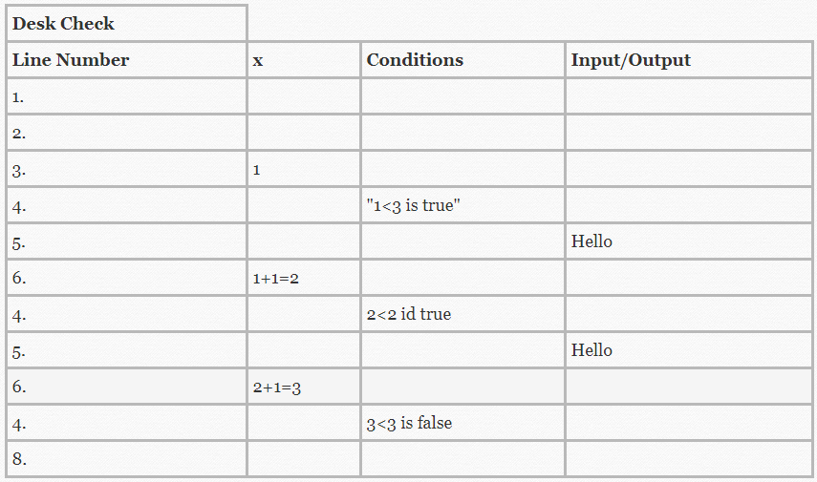

* Inexpensive and quick technique
* Less effective